|  |
| --- |
| **NATIONAL UNIVERSITY OF COMPUTER AND EMERGING SCIENCES**  **CS 201–DATA STRUCTURES LAB**  **Lab Session 05** |
| **Instructors:** Mr.Irfan, Ms. Mubashra |

Outline

* Linked List
* Task

**Linked List Basics**

A linked list is a sequence of data structures, which are connected together via links.

Linked List is a sequence of links which contains items. Each link contains a connection to another link. Linked list is the second most-used data structure after array. Following are the important terms to understand the concept of Linked List.

* **Link** − each link of a linked list can store a data called an element.
* **Next** − each link of a linked list contains a link to the next link called Next.
* **Linked-List** − A Linked List contains the connection link to the first link called First.

## Types of Linked List

Following are the various types of linked list.

* **Simple Linked List** − Item navigation is forward only.
* **Doubly Linked List** − Items can be navigated forward and backward.
* **Circular Linked List** − Last item contains link of the first element as next and the first element has a link to the last element as previous.

## Single Linked List:

## Representation

Linked list can be visualized as a chain of nodes, where every node points to the next node.

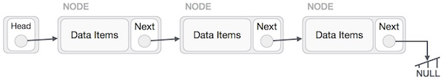

## Insertion Operation

Adding a new node in linked list is a more than one step activity. We shall learn this with diagrams here. First, create a node using the same structure and find the location where it has to be inserted.

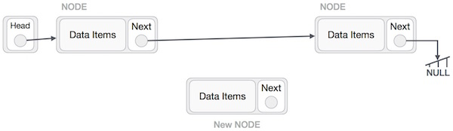

Imagine that we are inserting a node B (NewNode), between A (LeftNode) and C (RightNode). Then point B.next to C −

NewNode.next −> RightNode;

It should look like this −

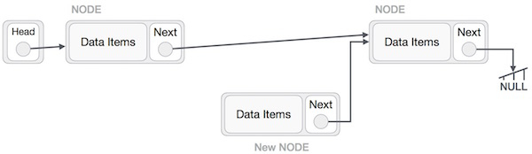

Now, the next node at the left should point to the new node.

LeftNode.next −> NewNode;

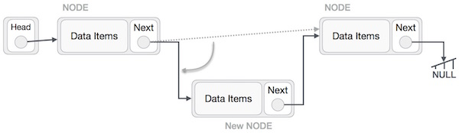

This will put the new node in the middle of the two. The new list should look like this −

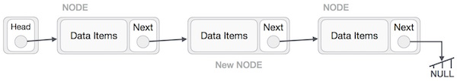

Similar steps should be taken if the node is being inserted at the beginning of the list. While inserting it at the end, the second last node of the list should point to the new node and the new node will point to NULL.

## Deletion Operation

Deletion is also a more than one step process. We shall learn with pictorial representation. First, locate the target node to be removed, by using searching algorithms.

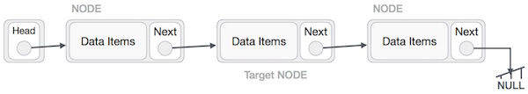

The left (previous) node of the target node now should point to the next node of the target node −

LeftNode.next −> TargetNode.next;

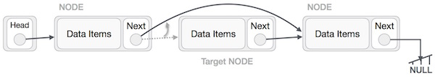

This will remove the link that was pointing to the target node. Now, using the following code, we will remove what the target node is pointing at.

TargetNode.next −> NULL;

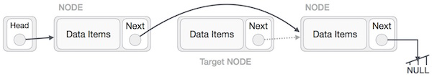

We need to use the deleted node. We can keep that in memory otherwise we can simply deallocate memory and wipe off the target node completely.

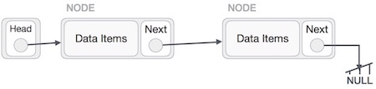

**Exercise:**

***Question #1***

Complete the following functions of LinkedList in the template provided on slate:

* void Insert_at_Head(int, Node*);//Insert at Start
* void Insert_at_End(int,Node*);//Insert at last
* void Insert_Before(int,Node*,int);//insert before a specific data
* void Insert_After(int, Node*,int);//Insert after a specific data
* void Insert_at(int,Node*,int);//Insert at a specific position
* void Delete_from_End(Node*);//Delete Last node
* void Delete_from_front(Node*);//Delete first node from front
* void Delete_at(int,Node*);// Detele at a specific Position
* void Delete_before(int,Node*);// Delete the node before the data
* void Delete_After(int,Node*);//Delete the node after the data
* void Display(Node*);//Displays the list
* int Search_data(int,Node*);//search the data and return the node number if present, else return -1.
* int Length_of_list(Node*);//counts the number of nodes in list

***Question #2***

Write a Count () function that counts the number of times a given int occurs in a list. The code for this has the classic list raversal structure as demonstrated in Length ().

void CountTest() {

List myList = BuildOneTwoThree(); // build {1, 2, 3}

int count = Count(myList, 2); // returns 1 since there's 1 '2' in the list

}

/*

Given a list and an int, return the number of times that int occurs

in the list.

*/

int Count(struct node* head, int searchFor) {

// Your code

***Question #3***

Write a program that prompts the users to enter 12 numbers. This program reads the numbers into a linked list. Make another Linked list that will store the average of numbers.

The two lists will be passed to a function for and the average will be calculated by

1. Take First Four nodes of "numbers list" calculate their average and store at first node in "Average linked list".
2. Next time skip the first node of "numbers list" and average the next 4 nodes and store at second node in Average linked list.
3. And this procedure will continue, until Average for all will be stored in Averagelist.